**COMP 3540 Advanced Web Design and Programming**

**Seminar/Lab 2.**

**Fundamental Concepts with Dropdown Menu**

1. **Objectives**

* Get yourselves familiar with the fundamental concepts of HTML and CSS.
  + Even-driven programming
  + Especially, displaying and positioning

1. **Dropdown menu**

* 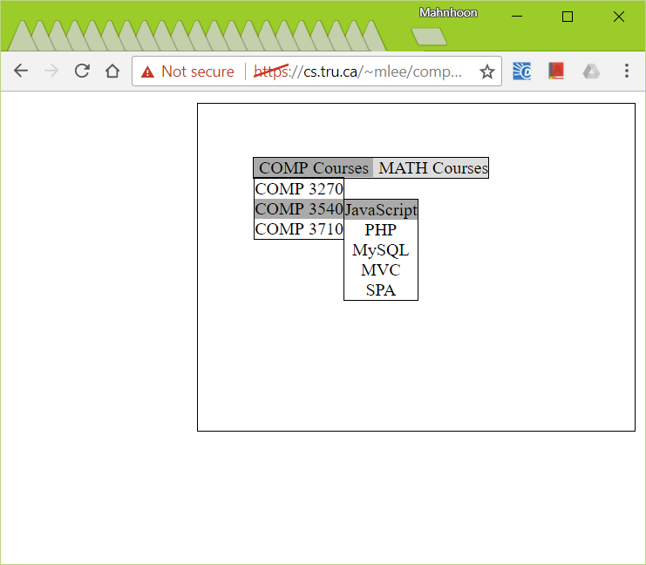Let’s make a dropdown menu with the following list within a menu container box of 400px × 300px.

<div class='ddm-container'>

<ul class='ddm'>

<li>COMP Courses

<ul>

<li>COMP 3270</li>

<li>COMP 3540</li>

<li>COMP 3710</li>

</ul>

</li>

<li>MATH Courses

<ul>

<li>MATH 1650</li>

<li>MATH 1700</li>

</ul>

</li>

</ul>

</div>

* + The menu container box should be displayed at the top and the right corner of the viewport.
  + The drop down menu should work properly. When the mouse hovers over a menu item, background color should be changed and the next level menu should be displayed.
* You can start with the posted dropdown_menu_client_student.html.
* Upload your program to cs.tru.ca, and **test it** before you submit it.

1. **Assignment**
   1. You will be given roughly 1 assignment or 2 assignments every week to help you understand all the topics in the lectures.
   2. Submission

* Submit the URL of the application in 2) by email.
* The URL should be accessible using a web browser. Otherwise you will get zero mark.
  + The title of the mail should include your name, id, and COMP 3540.
  + Due: 6:00 pm, January 19, 2018
* Total marks: 10
  + You need to complete the assignment. Usually no partial mark is given.
  + From the next week, you may need to submit seminar/lab assignments by the end of the class.
  + No late submission is accepted. Not even 1 second according to TRU email system.